

A report on

**“ANTICIPATING MENSTRUAL MIGRAINE USING DEEP LEARNING”**

**Submitted in partial fulfilment for the award of the degree of**

**BACHELOR OF TECHNOLOGY (Honors)**

**IN**

**COMPUTER SCIENCE & ENGINEERING**

**(DATA SCIENCE)**

Submitted by

**Pranav Polavarapu**

**19BTRCR008**

**Sushil Bokade**

**19BTRCR017**

**Sai Keerthi Chelluri**

**19BTRCR036**

**Sai Sharanya Y**

**19BTRCR043**

**Under the guidance of**

**Prof. Mohammed Zabeeulla A N**

**Faculty of Engineering & Technology**

**Jain (Deemed-To-Be University)**

**Department of Computer Science & Engineering** Jain Global Campus, Kanakapura Taluk - 562112 Ramanagara District,

Karnataka, India

**2022-2023**



### DEPARTMENT OF COMPUTER SCIENCE & ENGINEERING

Jain global campus, Kanakapura taluk Ramanagara District – 562112 Karnataka, India.

### CERTIFICATE

This is to certify that the project work titled **“ANTICIPATING MENSTRUAL MIGRAINE USING DEEP LEARNING”** is carried out by **Pranav Polavarapu (19BTRCR008), Sushil Bokade (19BTRCR017), Sai Keerthi Chelluri (19BTRCR036), Sai Sharanya Y (19BTRCR043),** a bonafide students of Bachelor of Technology at the Faculty of Engineering & Technology, Jain (Deemed- to-be University), Bangalore in partial fulfilment for the award of degree Bachelor of Technology (Honors) in Computer Science Engineering (Data Science), during the Academic year **2022- 2023**.

|  |  |  |
| --- | --- | --- |
| **Prof. Mohammed Zabeeulla A N** | **Dr. S.Ramesh** |  |
| Assistant Professor | Head Designation |  |
| Dept. of CSE | Dept. of CSE |  |
| Faculty of Engineering &Technology | Faculty of Engineering &Technology |  |
| Jain Deemed to be University | Jain Deemed to be University |  |
| Date: | Date: |  |

Name of the Examiner Signature:

1:

2:

# DECLARATION

We, **Pranav Polavarapu (19BTRCR008), Sushil Bokade (19BTRCR017), Sai Keerthi Chelluri (19BTRCR036), Sai Sharanya Y (19BTRCR043),** are students of eighth semester **B. Tech in Computer Science & Engineering (Data Science)**, at Faculty of Engineering & Technology, Jain (Deemed- To-Be University), hereby declare that the project work titled **“ANTICIPATING MENSTRUAL MIGRAINE USING DEEP LEARNING”** has been carried out by us and submitted in partial fulfillment for the award of degree in **Bachelor of Technology (Honors) in Computer Science & Engineering (Data Science)** during the academic year **2022-2023.**

Signature

**NAME 1: Pranav Polavarapu**

USN:19btrcr008

**Name 2:** Sushil Bokade

USN: 19BTRCR017

**Name 3:** Sai Keerthi Chelluri

USN: 19BTRCR036

**Name 4:** Sai Sharanya Y

USN: 19BTRCR043

Place: Bangalore

Date: 12/12/2022

# ACKNOWLEDGEMENT

*It is a great pleasure for us to acknowledge the assistance and support of a large number of individuals who have been responsible for the successful completion of this project work.*

*First, we take this opportunity to express our sincere gratitude to* ***Faculty of Engineering & Technology, Jain (Deemed-to-be University),*** *for providing us with a great opportunity to pursue our Bachelor’s Degree in this institution.*

*In particular we would like to thank* ***Dr. Hariprasad S A, Director, Faculty of Engineering & Technology, Jain (Deemed-to-be University),*** *for his constant encouragement and expert advice.*

*We place on record, our sincere thank you to* ***Dr. Geetha, Dean,******Faculty of Engineering & Technology****,* ***Jain (Deemed-to-be University),*** *for the continuous encouragement.*

*It is a matter of immense pleasure to express our sincere thanks to* ***Dr. S. Ramesh Program******Head****,* ***Computer Science & Engineering****,* ***Jain (Deemed- to-be University),*** *for providing right academic guidance that made our task possible.*

*It is a matter of immense pleasure to express our sincere thanks to* ***Prof. Mohamed Zabeeulla, Assistant Professor, Dept. of Computer Science & Engineering, Jain (Deemed- to-be University),*** *for providing right academic guidance that made our task possible.*

*We would like to thank our Project Coordinator* ***Dr. M. John Basha, Assistant Professor, Dept. of Computer Science & Engineering, Jain (Deemed- to-be University),*** *for providing right academic guidance that made our task possible.*

*We would like to thank our guide* ***Prof. Mohamed Zabeeulla, Assistant Professor****,* ***Dept. of Computer Science & Engineering****,* ***Jain (Deemed-to-be University),*** *for sparing his valuable time to extend help in every step of our project work, which paved the way for smooth progress and fruitful culmination of the project.*

*We would like to thank all the staff members of* ***Dept. of Computer Science & Engineering, Jain (Deemed-to-be University)****, for their support.*

*We are also grateful to our family and friends who provided us with every requirement throughout the course.*

*We would like to thank one and all who directly or indirectly helped us in completing the Project work successfully.*

*Signature of Students*

# Table of Contents

Certificate ii

Declaration iii

Acknowledgment iv

Table of Content v

Abstract vii

List of Figures viii

Chapter 1

1. INTRODUCTION 9
   1. Overview 9
   2. Problem Definition 10
   3. Objective 11
   4. Methodology 12

Chapter 2

1. LITERATURE SURVEY 14
   1. Existing System 18
   2. Limitations of existing system 19
   3. Proposed System 20
   4. Advantages of Proposed System………………………………………………………………………………21

Chapter 3

1. TOOL DESCRIPTION 22
   1. Hardware Requirements 22
   2. Software Requirements 23

Chapter 4

1. IMPLEMENTATION... 24

Conclusion And Future Scope 25

References 26

Appendix-I 27

# ABSTRACT

Menstrual Migraines are headaches that occur without any typical aura or sensory disturbances. They can be labelled as **'Migraine without Aura'**. A woman could undergo menstrual migraine just before or during her period starts. This is majorly due to the drop in estrogen levels in the body. Menstrual migraines can be intense, & they must be identified accurately & treated separately from regular ones. Anticipating Menstrual Migraines using Deep Learning methodology can help women in taking precautions beforehand and aid in improving their health. This paper provides an efficient approach by testing multiple deep learning approaches and implementing ANN model with tuned hyperparameters providing stronger accuracy.

# List of Figures

|  |  |  |
| --- | --- | --- |
| Fig No. | Description of the figure | Page No. |
| 1 | Relation between Duration and Migraine type. | 11 |
| 2 | Relation between Frequency and Migraine type. | 12 |
| 3 | Relation between Visual and Migraine type. | 12 |
| 4 | Distribution of feature age. | 12 |
| 5 | Hormone Fluctuations During the Lifecycle of a Woman [10]. | 18 |
| 6 | Flowchart for Menstrual Migraine Classification procedure. | 20 |

# Chapter 1

## Introduction

### Overview

There is a link between migraine and hormonal changes in a woman’s life, this type of migraine is known as menstrual migraine, it is a primary classification type of migraine caused mostly in 20-30 age group women which starts two days prior to periods and ends three post the menstrual cycle, this migraine recurs along every month periodic cycle. Although doctors typically diagnose migraine in women who report with persistent, incapacitating headaches, they first need to rule out other headache conditions. Assessment of the impact of hormones (such as menses) on these recurrent incapacitating headaches is necessary for women who fit the criteria for migraine (International classification criteria, 2004). For menstrual related migraine (MRM), often known as pure menstrual migraine, many women fit the requirements (PMM).

Dysmenorrhea is strongly associated to menstruation in itself. Women who are taught to distinguish between the symptoms of PMDD (Premenstrual dysphoric disorder) and migraines will be better able to control their migraine attacks. These are listed as follows in the International Classification Criteria Appendix:

#### Pure menstrual migraine:

Pure menstrual migraine that doesn't have an aura meets the diagnostic standards for migraine without an aura and episodes only happen on day 12 of menstruation and never at any other period during the cycle, according to at least two out of every three menstrual cycles.

#### Menstrual related migraine without aura:

Episodes occur on day12 (i.e., days -2 to +3) of menstruation in at least two out of three menstrual cycles and also at other periods of the month, and they fulfil the diagnostic criteria.

Menstrual migraine symptoms are analogous to those of other types of migraines. subtle or extremely painful headache is the most common symptom followed by other various symptoms like feeling very hot or chilly, sensitivity to sounds and odors and light, sensitive scalp, decrease in appetite, vision blur and dizziness light skin tone, being worn out, abdominal pain, stomach distress, and nausea, a fever or diarrhea.

### Problem Definition

It is important to correctly diagnose and treat menstrual migraines separately from other types of migraines since they can be very severe. We need a deep learning approach to predict menstrual migraines so that women can take preventative measures and enhance their health. Since this is for medical usage, we require an effective procedure with excellent precision.

### Objective

This project aims to build an automated system that identifies, classifies, and anticipates an occurrence of Menstrual Migraine in women. This is based on the severity of symptoms that a woman experiences – like throbbing, periods, Nausea, visual disturbances, intensity, & many more. The data collected from a woman is cleaned & modeled into the Deep Learning Classification system that identifies the type of migraine occurring (Menstrual | non-Menstrual | Others). This classification system can be integrated with period-tracking applications and cloud-based systems to scale up the impact created on a woman's health. The project enables women to consider prior precautions & medication in cases of menstrual-related migraine.

### Methodology

#### Data Collection:

Real time survey has been conducted by the team where the symptoms and their severity has been collected from individual patients in a secure manner and was converted to csv format for easy access to data and it’s processing.

#### Importing required libraries:

For complex data computation and data preprocessing, NumPy and pandas are used. For visualizing the correlations matplotlib and seaborn are used and then multiple methods like resample, label encoder, evaluation metrics are imported from sci-kit learn library Keras and TensorFlow libraries are used for building neural network with activation functions sigmoid and Relu.

#### Feature Engineering:

Primarily data has been cleaned by handling missing values using data imputation methods and then the categorical data has been encoded based on the number of classes wherein we used label encoding and replace methods.

#### Exploratory Data Analysis:

The correlation between features and the target variable has been analyzed using various Exploratory Data Analysis methodologies. Count and percentage charts along with various other charts like violin charts, histograms, bar charts, boxplots were used to visualize and gain insights from the feature relations.

#### Model Building:

ANN is the base model used with thirty hidden layers with Relu activation function for the hidden layers and SoftMax function for output layer and finally compiled using Adam optimizer and loss function as categorical cross-entropy, Keras classifier has been created over the baseline model with 1000 epochs and batch size of 75.

#### Cross validation:

K-fold cross validation has been used with k value of 15 in order to optimize the classification model.

#### Correlation Plots:

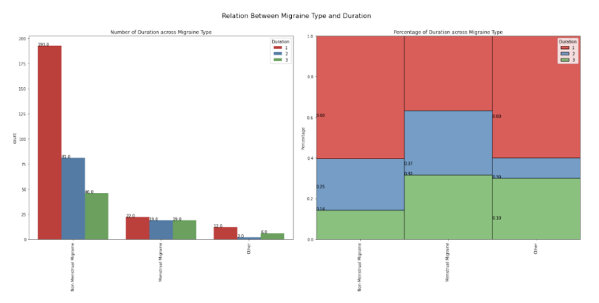

Figure 1. Relation between Duration and Migraine type.

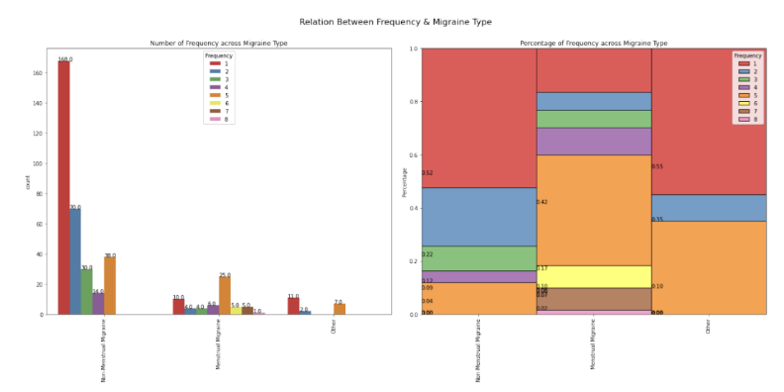

Figure 2. Relation between Frequency and Migraine type.

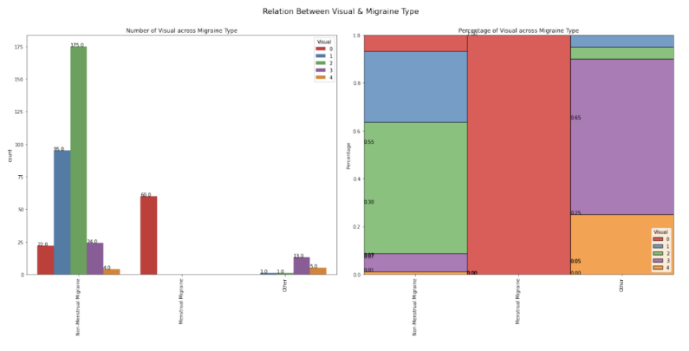

Figure 3. Relation between Visual and Migraine type.

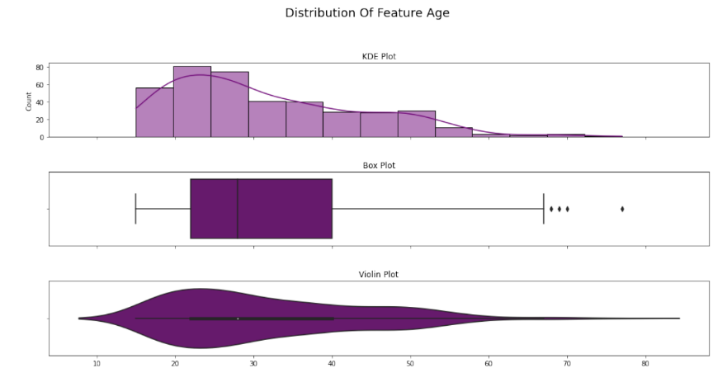

Figure 4. Distribution of feature age.

# Chapter 2

## Literature Survey

* Ahmet, Alkan, and Batuhan Akben Selahaddin [1]

This paper describes different migraine detection methods have been proposed in former researches. But these former researches are generally based on frequency domain analysis of EEG data. Due to frequency domain transformation of EEG data, complex mathematical algorithm is needed. The beta band of each flash stimulated and non-stimulated EEG data for both migraine patients and healthy subjects are filtered by employing the FIR filter. If figures are compared it can be seen that, the beta band of EEG signals has lower amplitudes. Then for all filtered EEG data, the time domain-based preprocessing technique, namely histogram is applied. The result shows the effect of flash stimulation on the beta band of EEG data of healthy and migraineur subjects. In this study, a time domain-based histogram technique was used as a preprocessing technique to extract features, to cluster healthy subjects and migraine patients from flash stimulated and non-stimulated EEG signals. It is observed that, the amplitude frequency histograms (Cluster 2) clustered very well with silhouette values greater than or equal to 0.63 for migraine patients. Also, the similar achievements are obtained for healthy subjects. For all the data correct clustering accuracy can be calculated as 86.6% by using the information from Figures obtained.

* Akben, Selahaddin Batuhan, Abdulhamit Subasi, and Deniz Tuncel [2]

Here the most effective flash stimulation frequency and the least time period to diagnose the migraine is determined. First aim of this study was to determine the best flash stimulation frequency to detect the migraine. Hence, it determined the most effective flash stimulation frequency as 4 Hz to detect the migraine. Second aim is the determination of the least time period to detect the migraine. It was found that the minimum time period as 8 s to diagnose the migraine. According to this result, it is determined that the best flash stimulation frequency and least time period in EEG recordings for migraine detection based on magnitude increase at the beta band of EEG signal in T5-T3 channel.

* Akben, Selahaddin Batuhan, Abdülhamit Subaşı, and Mahmut Kemal Kıymık [3]

The paper published that 23% of human has a migraine disease which is a painful and throbbing brain disorders. Cause of migraine isn't known and accepted automatic diagnose method of migraine by biomedical equipment isn't available yet. To obtain information about migraine generally change of EEG signals under flash stimulation is used as a method. In this study aim is performance analysis of classification methods of EEG signals obtained from stimulated migraine patient by flash light for automatic migraine diagnose. Firstly, EEG signals obtained from both migraine patients and healthy subjects are transformed to frequency domain by using (AR) Burg method. And these frequency spectrums are classified by using artificial neural network and support vector machine classification algorithm. According to these classification results which classification algorithm has a better performance for migraine diagnose is determined.

* Charles, Andrew [4]

The migraine aura is a dramatic neurologic event with complex neural and vascular mechanisms and has potentially important implications regarding diagnostic and therapeutic management. Refined understanding of its clinical features, comorbidities, patterns of propagation in the human brain, and specific responses to therapy can add important new insight into the pathophysiology of migraine and its optimal therapy.

* Chong, Catherine D., Nathan Gaw, Yinlin Fu, Jing Li, Teresa Wu, and Todd J. Schwedt [5]

Classification of migraine using rs-fMRI provides insights into pain circuits that are altered in migraine and could potentially contribute to the development of a new, noninvasive migraine biomarker. Migraineurs with longer disease burden were classified more accurately than migraineurs with shorter disease burden, potentially indicating that disease duration leads to reorganization of brain circuitry.

* Ang, Kai Keng, Cuntai Guan, Kerry Lee, Jie Qi Lee, Shoko Nioka, and Britton Chance [6]

Near-infrared spectroscopy (NIRS) enables non-invasive recording of cortical hemoglobin oxygenation in human subjects through the intact skull using light in the near-infrared range to determine. This paper proposes a novel BCI for detecting changes resulting from increases in the magnitude of operands used in a mental arithmetic task, using data from single-trial NIRS brain signals. We measured hemoglobin responses from 20 healthy subjects as they solved mental arithmetic problems with three difficulty levels. Accuracy in recognizing one difficulty level from another is then presented using 5×5-fold cross-validations on the data collected. The results yielded an overall average accuracy of 71.2%, thus demonstrating potential in the proposed NIRS-based BCI in recognizing difficulty of problems encountered by mental arithmetic problem solvers. Copyright © 2010 by The Institute of Electrical and Electronics Engineers, Inc. All rights reserved.

* Garcia-Chimeno, Yolanda, Begonya Garcia-Zapirain, Marian Gomez-Beldarrain, Begonya Fernandez-Ruanova, and Juan Carlos Garcia-Monco [7]

The proposed feature selection committee method improved the performance of migraine diagnosis classifiers compared to individual feature selection methods, producing a robust system that achieved over 90% accuracy in all classifiers. The results suggest that the proposed methods can be used to support specialists in the classification of migraines in patients undergoing magnetic resonance imaging. When classifying the migraine group, the greatest improvements in accuracy were made using the proposed committee-based feature selection method. Using this approach, the accuracy of classification into three types improved from 67 to 93% when using the Naive Bayes classifier, from 90 to 95% with the support vector machine classifier, 93 to 94% in boosting. The features that were determined to be most useful for classification included are related with the pain, analgesics and left uncinate brain (connected with the pain and emotions).

* Jackowski, Konrad, Dariusz Jankowski, Dragan Simić, and Svetlana Simić [8],

A valid diagnosis of migraine is a non-trivial decision problem. The paper presents an ensemble classifier system designed for headache diagnosis. Here it is assumed that the system should make fast initial diagnosis based on an analysis of data collected in the questionnaire only. Such an assumption eliminated possibility of application of most classical classification algorithms as they could not obtain decent level of accuracy. Therefore, it is decided to apply an ensemble solution. Thus, we applied two stages strategy. Firstly, large pool of elementary classifiers was prepared. Its diversity was ensured by selecting algorithms of different types, structures, and learning algorithms. Secondly, we determined optimal size of the ensemble and selected its constituents using exhaustive search approaches. Results of experiments, which were carried on dataset collected in University of Novi Sad, shows that proposed system significantly outperformed all classical methods. Additionally, we present analysis of diversity and accuracy correlation for tested systems.

* Sanchez-Sanchez, Paola A., José Rafael García-González, and Juan Manuel Rúa Ascar [9]

In here the study presents the development of a methodology for migraine classification using artificial neural network models. The results show that artificial neural networks can achieve higher precision and accuracy than other classification models commonly used in machine learning, which is consistent with the results found when compared with various models proposed in the literature. The first experiments included 24 variables involved in migraine diagnosis, achieving a 97% precision level for the artificial neural network model. However, a second testing phase reduced the set of variables to 18, reaching a precision of 98%. This not only proves that the artificial neural network model is effective for the proper classification of the different types of migraine but shows that it can also be improved by considering a reduced set of variables that significantly affect the classification.

* Silberstein, Stephen D., and Susan L. Hutchinson [10]

This paper states Estrogen decline is associated with exacerbation in migraine in susceptible women. These women often have a diagnosis of MRM or PMM, and they may also have other non-headache symptoms that are due to variations in circulating hormone levels (e.g., anxiety, depression, dysphoria, among others). Differential diagnosis is an important part of successfully identifying the type of headache so treatments may be prescribed accordingly. Assessment of non-pain symptoms will also influence treatment decisions and therefore, frequency, severity, non-pain symptoms and disability all need to be fully assessed in relation to hormonal influences. For many women with MRM, monotherapy can be successful in treating all their attacks, whether associated with menstruation or not. However, such an approach may not be sufficient for all women, and some may need short or long-term prevention in addition to acute treatment and rescue medications. Polytherapy may also extend to treat coexisting conditions or symptoms (e.g., PMDD, depression, anxiety, among others).Although migraine associated with changes in circulating estrogen levels is now a well-accepted clinical phenomenon, treatment aimed at modifying plasmaestrogenlevelsisstillunderinvestigation.Randomized,double-blind,long-term controlled trials are warranted to further assess the optimal strategy and effective treatments for hormonal treatment of migraine associated with estrogen fluctuations.

## Existing Work

One of the extant papers describes the creation of a methodology used exclusively for just migraine categorization using artificial neural network models. The findings are congruent with those observed when multiple models described in the literature are compared, showing that artificial neural networks can attain higher precision and accuracy than existing classification models frequently employed in machine learning. In the initial studies, 24 migraine diagnosis-related variables were used, and the artificial neural network model's precision level was 97%. However, a second testing phase decreased the number of variables to 18, achieving a precision of 98%. Furthermore, it demonstrates that the artificial neural network model may be enhanced by taking into account a smaller collection of variables that have a substantial impact on the classification, demonstrating that it is useful for correctly classifying the various forms of migraine [9]. The phases of a woman's life cycle when her vulnerability to headaches changes is linked to her shifting hormonal environments. The body's hormonal environment changes four times throughout the day. In a study involving 556 postmenopausal women, Neri and colleagues examined the prevalence of primary headaches. 13.7% of individuals reported having headaches, and 82% of them reported having headaches before the start of menopause. Sixty-two percent said they suffered migraines without an aura, and the remaining people said they had tension headaches. Nobody who took part in the study got a cluster headache or a migraine with aura. With physiologic menopause, two-thirds of women who had previously experienced migraines got better; in contrast, two-thirds of women who underwent surgical menopause experienced migraine exacerbation. These studies collectively demonstrate that migraine frequency and intensity alter over the course of the female life cycle, and that this may be partly because of the continuously shifting hormonal milieu [10].

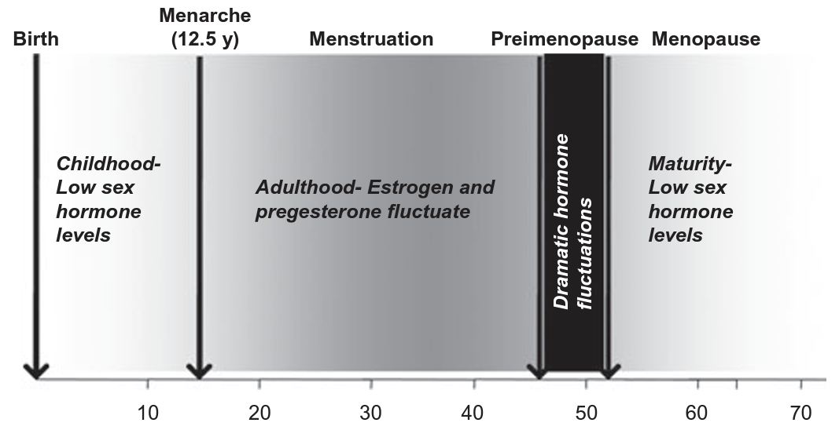

Figure 5. Hormone Fluctuations during the lifecycle of a woman.

### Limitations in Existing System

* The Main limitation in here stands that ML/AI and Deep learning was only used for Migraine in general but not for Menstrual Migraine as such.
* **Use of K-means clustering in migraine detection by using EEG records under flash stimulation.**
  + Based upon analyzing brain wave signals. Requires resources and is inefficient.
* **Analysis of repetitive flash stimulation frequencies and record periods to detect migraine using ANN.**
  + Complex process of analyzing frequencies over time. Requires long duration and equipment to just detect migraine.
* **Comparison of artificial neural network and support vector machine classification methods in diagnosis of migraine by using EEG.**
  + Similar to the previous ones.
* **The Migraine Aura.**
  + Only intended to identify migraine with Aura (unrelated to non-aura migraines).
* **Migraine classification using magnetic resonance imaging resting.**
  + Just provided insights upon pain circuits in the brain that acted as biomarkers to identify migraine patients.
* **Migraine classification by ML with functional near-infrared spectroscopy during the mental arithmetic task.**
  + fNIRS & hemoglobin analysis is not quite the easy or standard way to quickly identify the types of migraine.
* **Automatic migraine classification via feature selection committee and ML techniques over imaging and questionnaire data.**
  + DTI images & IQ questionnaires are a complex process to create classification models. Lot of scope for optimization.
* **Migraine Diagnosis Support System Based on Classifier Ensemble.**
  + Does not provide any insights into types of migraines based on aura, and null on menstrual-related migraines.
* **Automatic migraine classification using artificial neural networks.**
  + No significant EDA performed. Increased dimensions and incomprehensible correlations among the variables. Leaves scope for efficient system to build over neural networks (other than old MLP Classifier)
* **Diagnosis and Treatment of the Menstrual Migraine Patient.**
  + Provides a perspective into post-identification procedures & treatments for women with menstrual migraine.

## Proposed System

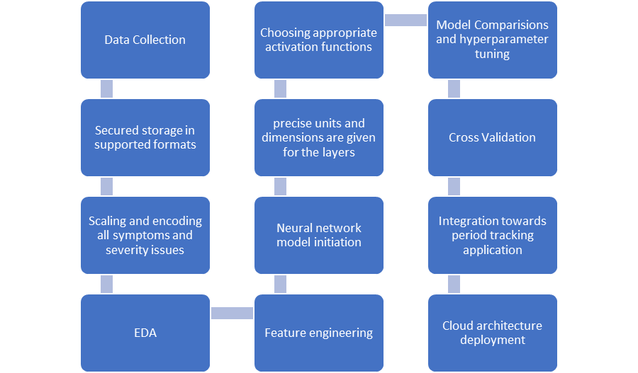

Figure 6. Flowchart for Menstrual Migraine Classification procedure.

## Advantages of Proposed System

The designed system will be implemented on 24 attribute datasets containing 400 instances diagnosed with various migraine associated pathologies. The data has been collected through multiple real time surveys and also took support from code ocean capsule data. The Bengaluru region has been surveyed through google forms containing multiple questionnaires regarding their age, duration of migraine, frequency, location of the migraine, its intensity are factors that play major role in the migraine classification decision. Few other important factors are also considered to classify the target variable into three different categories I.e., “Menstrual Migraine”, “Non-Menstrual Migraine” and other. Primarily the correlation between the target variable and other features have been displayed through count and percentage plots, showing their variability in a precise manner. Then the data is pre-processed thoroughly by performing data cleaning, data encoding, missing data evaluation along with data visualization for analyzing the symptom severity along the type of migraine and their correlation. ANN classifier has been deployed to gain required classification predictions. Below is the flowchart describing the process steps.

# Chapter 4

## Tool Description

### 4.1. Hardware Requirements:

* Processor: 8th Gen i5
* Ram: 8GB
* 64-bit Operating System
* x64 – based processor

### 4.2. Software Requirements:

* NumPy
* Pandas
* Seaborn
* Matplotlib
* Sci-kit learn
* Python 3.10
* IDE

# Chapter 5

## Implementation

Based on the data collected and the feature correlation it is anticipated that age plays a major role for menstrual migraine prediction and evaluating the symptom severity. The deep learning model was optimized using k-fold cross validation and giving an optimized model holding recall value 0.94 and a precision of 0.89 and with an accuracy of 90.002 %.

## Conclusion and Future Scope

This is the first model to be implemented for menstrual migraine prediction, this provides an easier diagnostic approach to recognize the migraine type during the menstruation period which helps women get early access to appropriate treatment. The developed model can be integrated with period trackers providing complete information to the user regarding their migraine health condition during menstruation and suggest appropriate remedies based on the feature evaluation.

## References

[1] Ahmet, Alkan, and Batuhan Akben Selahaddin. "Use of k-means clustering in migraine detection by using EEG records under flash stimulation." International Journal of Physical Sciences 6, no. 4 (2011): 641-650.

[2] Akben, Selahaddin Batuhan, Abdulhamit Subasi, and Deniz Tuncel. "Analysis of repetitive flash stimulation frequencies and record periods to detect migraine using artificial neural network." Journal of medical systems 36, no. 2 (2012): 925-931.

[3] Akben, Selahaddin Batuhan, Abdülhamit Subaşı, and Mahmut Kemal Kıymık. "Comparison of artificial neural network and support vector machine classification methods in diagnosis of migraine by using EEG." In 2010 IEEE 18th Signal Processing and Communications Applications Conference, pp. 637-640. IEEE, 2010.

[4] Charles, Andrew. "The migraine aura." Continuum: Lifelong Learning in Neurology 24, no. 4 (2018): 1009-1022.

[5] Chong, Catherine D., Nathan Gaw, Yinlin Fu, Jing Li, Teresa Wu, and Todd J. Schwedt. "Migraine classification using magnetic resonance imaging resting-state functional connectivity data." Cephalalgia 37, no. 9 (2017): 828-844.

[6] Ang, Kai Keng, Cuntai Guan, Kerry Lee, Jie Qi Lee, Shoko Nioka, and Britton Chance. "A brain-computer interface for mental arithmetic task from single-trial near-infrared spectroscopy brain signals." In 2010 20th International Conference on Pattern Recognition, pp. 3764-3767. IEEE, 2010.

[7] Garcia-Chimeno, Yolanda, Begonya Garcia-Zapirain, Marian Gomez-Beldarrain, Begonya Fernandez-Ruanova, and Juan Carlos Garcia-Monco. "Automatic migraine classification via feature selection committee and machine learning techniques over imaging and questionnaire data." BMC medical informatics and decision making 17, no. 1 (2017): 1-10.

[8] Jackowski, Konrad, Dariusz Jankowski, Dragan Simić, and Svetlana Simić. "Migraine diagnosis support system based on classifier ensemble." In International conference on ICT innovations, pp. 329-339. Springer, Cham, 2014.

[9] Sanchez-Sanchez, Paola A., José Rafael García-González, and Juan Manuel Rúa Ascar. "Automatic migraine classification using artificial neural networks." F1000Research 9 (2020).

[10] Silberstein, Stephen D., and Susan L. Hutchinson. "Diagnosis and treatment of the menstrual migraine patient." Headache: The Journal of Head and Face Pain 48 (2008): S115-S122.

### Appendix – I

|  |  |  |  |  |
| --- | --- | --- | --- | --- |
| STUDENT NAME | EMAIL ID | PERMANENT  ADDRESS | PHONE  NUMBER | PHOTOGRAPH |
| Pranav Polavarapu |  |  |  |  |
| Sushil Bokade | bokadesushil@gmail.com | Royal Red Wood Apartment, Gaurav Nagar, JP Nagar 7th Phase, Bengaluru, Karnataka, India - 560078 | +91776886412 |  |
| Sai Keerthi Chelluri |  |  |  |  |
| Sai Sharanya Y |  |  |  |  |